Instruction guide
1.environment:
The following table is the working environment of the author of this article
Table 1 Software and hardware environment
Operating System | Ubuntu 16.04
Programming Language | Python 3.6/C++
Deep Learning Framework | Tensorflow 2.0
CPU | Intel(R) Xeon(R) Gold 6126 CPU @ 2.60GHz 48core
GPU | 4*Tesla T4_16GB
Memory | 256GB
It is recommended to configure the software and hardware environment in the manner shown in the table, but it is not necessary. Among them, Python3.6 and tensorflow2.0 environment are required. A multicore CPU, a High-performance GPU with enough memory are necessary.

Need to install python matplot library, it is recommended to use the command:
python -m pip install matplotlib

2.training
File：3Dinversion64.py
Before training, you need to change the path of these files in the file. They are provided with the same file name in the test_data directory.
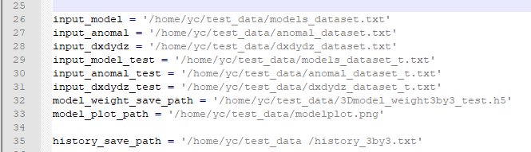
“input_model & input_dxdydz” are the input of the training dataset file，”input_anomal” is the label of the training dataset，
“Input_model_test & input_dxdydz_test” are the input of test dataset，”input_anomal_test” is the labels of testing dataset.
“model_weight_save_path” is the save path of training weights. ”history_save_path” is the path to save the error record of training.
Enter the command line to start training:
Python 3Dinversion64.py
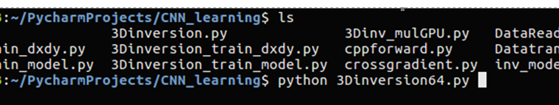
Obtain the following output indicating that the training begins.
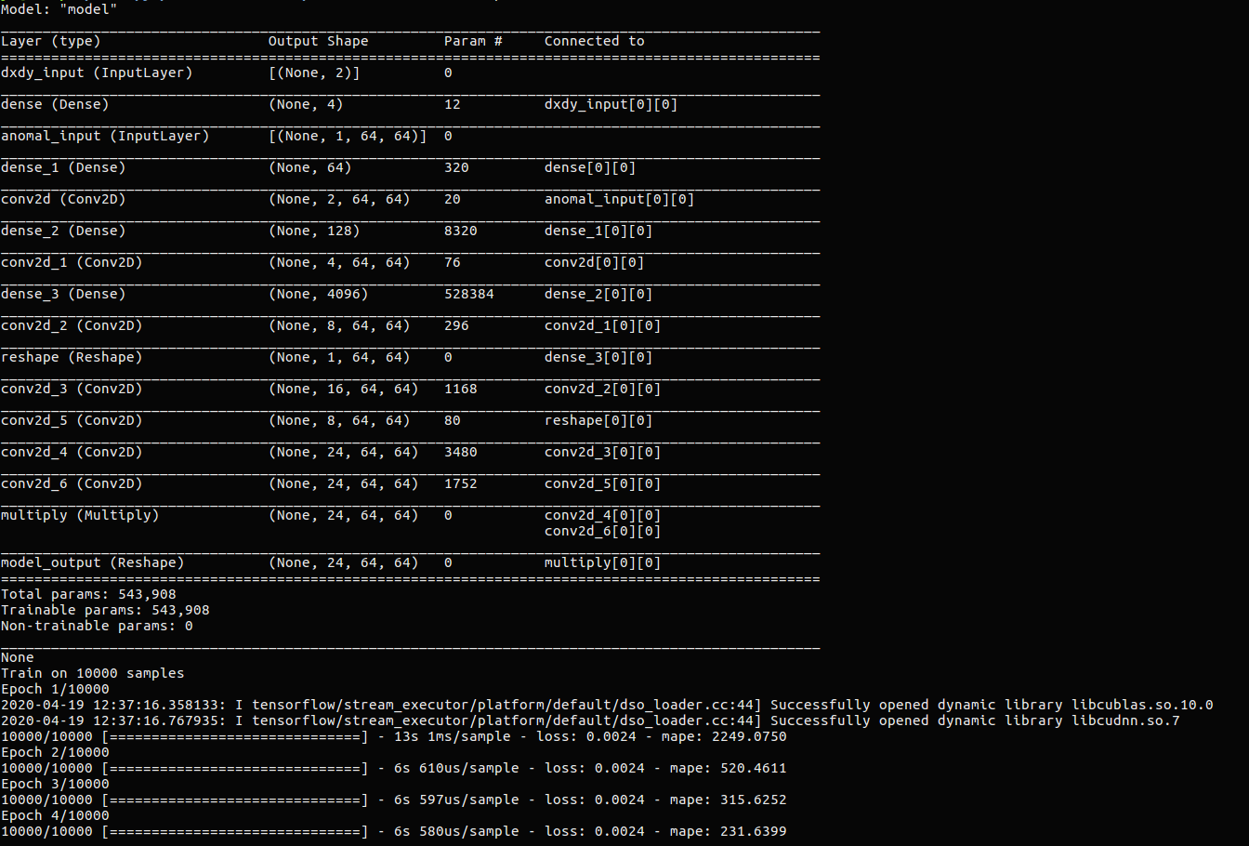
Tips: we do not provide a complete data set for confidentiality purposes, because part of the data is synthesized based on real gravity data and the size limit of uploaded file. We provide a very small data set and training set and they are exactly the same, but still allows the program to run. Although we did not provide a large data set, we have provided a trained weight in the test_data directory.
2. prediction (inversion):
File: main_predict64.py
The path in the file needs to be changed before predicting. These files are provided in the test_data folder。
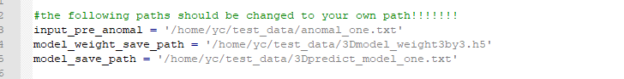
“input_pre_anomal” is the input observed gravity anomal
“model_weight_save_path” is the weight we have already trained
“model_save_path” is the prediction of the underground model

Enter the command line to start predicting:
Python main_predict64.py
Obtain the following output indicating that the predicting begins.
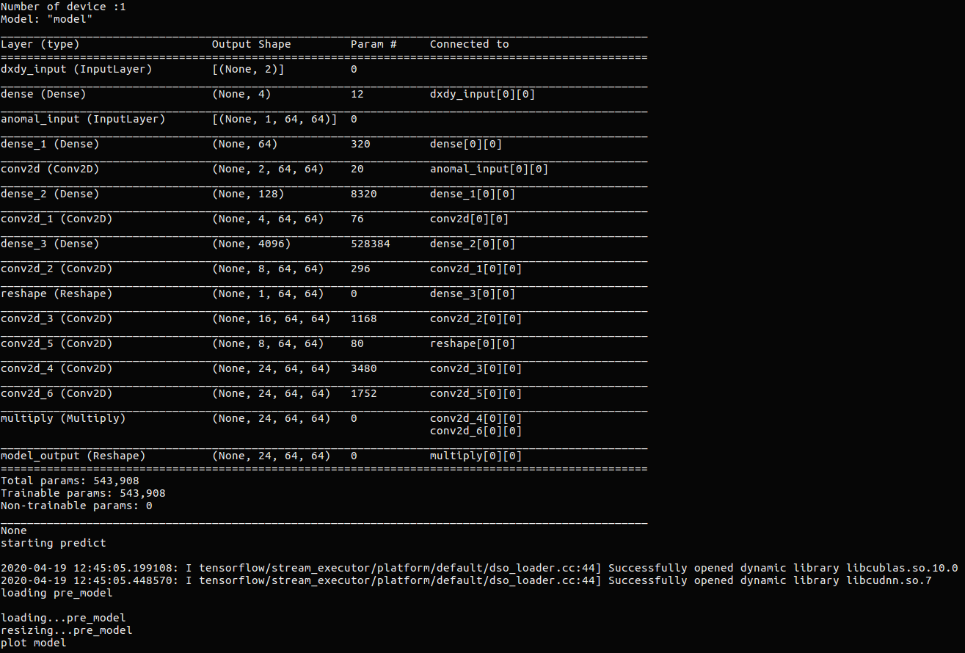
(input, observed anomal)
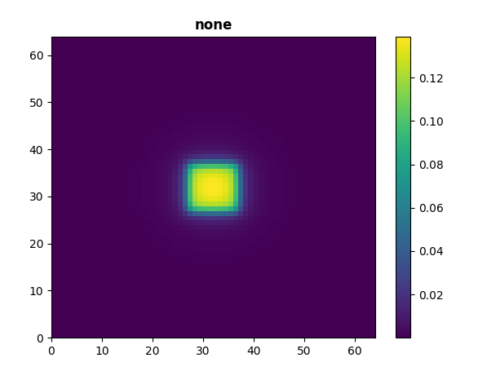
(output, predicting model)
